Indian Institute of Technology, Patna


MA3206:
AI Assignment

Report – Lab Assignment 5

Submitted To: | Submitted By:
Dr. Ranjeet Ranjan Jha | Aditya Gupta  2301MC51  Aditya Onam  2301MC60  Shakib Akhtar  2301MC49  Mohit Kumar  2301MC47

MDP Policy Evaluation, Value Iteration, and Policy Iteration
1. Problem Formulation
This assignment models a battery-powered autonomous robot as a Markov Decision Process (MDP) with the objective of maximizing long-term cumulative reward while balancing operational productivity and energy constraints.
The MDP is formally defined as follows:
- State Space
$$S=\{\text{High},\text{Low},\text{Charging}\}$$These represent the robot’s battery levels.
- Action Space
$$A=\{\text{Search},\text{Wait}\}$$
- Discount Factor
$γ=0.9$, emphasizing long-term reward optimization.
- Convergence Threshold
$θ={10}^{-6}$, ensuring numerical stability in iterative algorithms.
- Transition Dynamics & Rewards
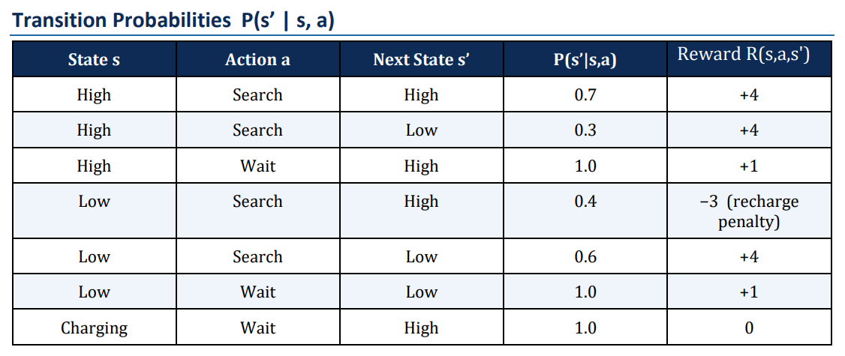
Defined explicitly in the table, where:
  - Searching in High yields high reward but risks battery drop.
  - Searching in Low carries a recharge penalty risk.
  - Charging deterministically restores the battery to High.
This structured formulation enables the application of dynamic programming methods to compute optimal decision policies.

2. Task 1: Iterative Policy Evaluation
2.1 Objective
The goal is to evaluate a fixed policy $π$ by computing the value function $V^{π}(s)$, representing the expected cumulative discounted reward from each state.
The Bellman Expectation Equation is:
$$V(s)=\sum_{s^{'}}{P(}s^{'}∣s,π(s))\left[R(s,π(s))+γV(s^{'})\right]$$
2.2 Evaluated Policy
$$π(\text{High})=\text{Search},π(\text{Low})=\text{Wait},π(\text{Charging})=\text{Wait}$$
2.3 Results
The iterative algorithm converged after 133 iterations, satisfying the convergence threshold.
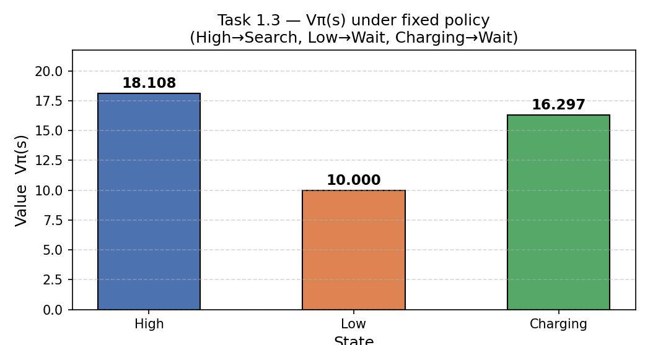

The resulting value function is:
- $V^{π}\left(\text{High}\right)=18.108 V^{π}(\text{Low})=10.000$ $V^{π}(\text{Charging})=16.297$

2.4 Interpretation
- The High state yields the largest value due to frequent access to high rewards from searching.
- The Low state is conservative under the chosen policy (Wait), leading to lower returns.
- The Charging state has no immediate reward but transitions to High, hence inherits moderate value.
3. Task 2: Value Iteration
3.1 Objective
Value Iteration directly computes the optimal value function $V^{*}(s)$by repeatedly applying the Bellman Optimality operator.
$$V(s)={max⁡}_{a}\sum_{s^{'}}{P(}s^{'}∣s,a)\left[R(s,a)+γV(s^{'})\right]$$
3.2 Results
The algorithm converged after 142 sweeps.
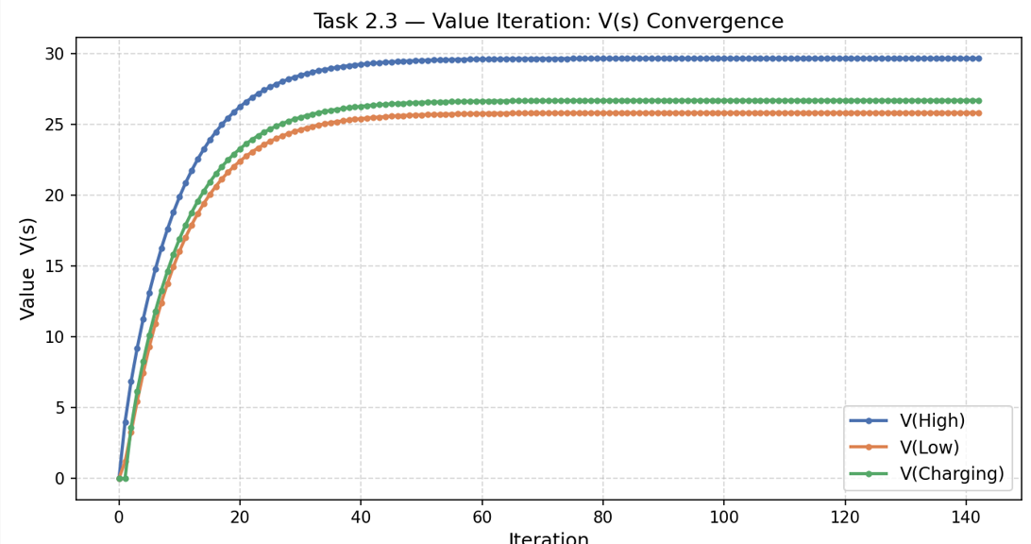

Optimal Value Function
- $V^{*}(\text{High})=29.644$ $V^{*}(\text{Low})=25.808$ $V^{*}(\text{Charging})=26.679$
Optimal Policy
- High → Search
- Low → Search
- Charging → Wait
3.3 Convergence Behavior
The convergence plot (Task 2.3) shows:
- Smooth, monotonic increase in values
- Gradual stabilization to a fixed point
This reflects the contraction property of the Bellman operator under $γ<1$.

4. Task 3: Policy Iteration
4.1 Objective
Policy Iteration alternates between:
- Policy Evaluation
- Policy Improvement

4.2 Execution
- Initial Policy:
$$π_{0}=[\text{Wait},\text{Wait},\text{Wait}]$$
4.3 Results
The algorithm converged in 2 outer iterations, demonstrating high efficiency.
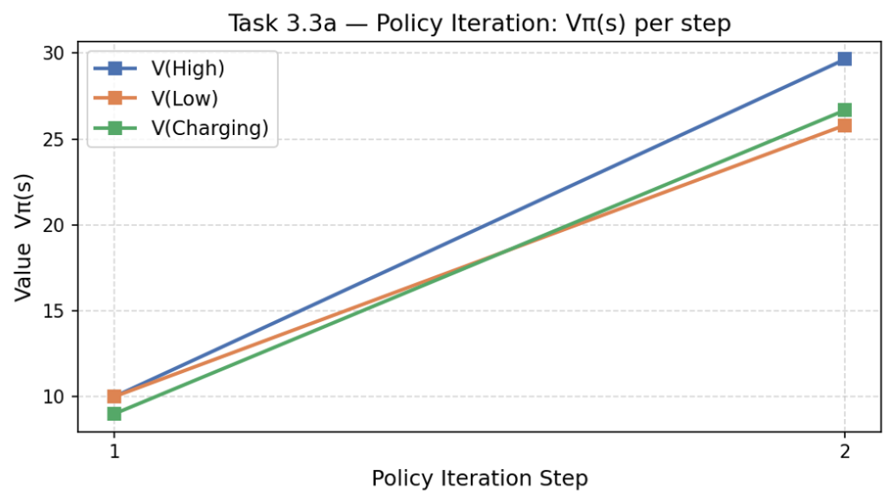

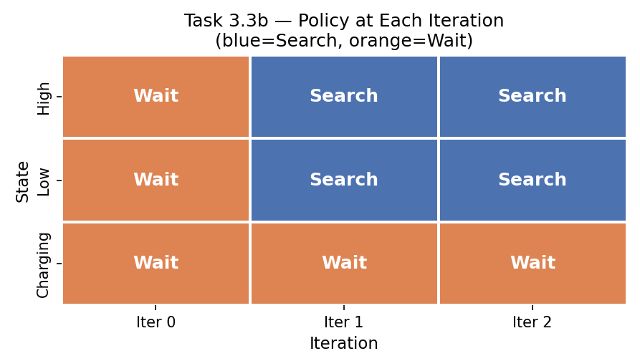

Iteration Summary
- Iteration 1
  - Policy: [Wait, Wait, Wait]
  - Value: $\left[10.0 , 10.0 , 9.0\right]$
- Iteration 2
  - Policy updated to: [Search, Search, Wait]
  - Value function matched $V^{*}$
- Policy stabilized thereafter.

4.4 Visualization Insights
- The line plot shows a sharp increase in value after the first improvement step.
- The policy heatmap shows immediate transition from all-Wait to optimal configuration.

5. Task 4: Analysis and Interpretation
5.1 Value Iteration vs Policy Iteration
- Value Iteration: 142 iterations
- Policy Iteration: 2 iterations
Explanation:
Value Iteration performs incremental updates without committing to a policy, requiring many sweeps for convergence.
Policy Iteration, in contrast, performs full policy evaluation, leading to highly informed updates and rapid convergence.

5.2 Convergence Behavior
- The Bellman operator is a contraction mapping, ensuring convergence to a unique fixed point.
- Values increase monotonically from initialization $V=0$.
- The Charging state stabilizes between Low and High due to deterministic transition to High with zero reward.

5.3 Optimal Policy Interpretation
- High → Search
High immediate reward (+4) outweighs the risk of transitioning to Low due to strong future returns.
- Low → Search
Despite recharge penalty risk, expected reward (~1.2) exceeds waiting (1.0), and access to High state improves long-term gain.
- Charging → Wait
Only feasible action; acts as a deterministic reset to High.

5.4 Practical Insights
This MDP formulation provides a principled alternative to heuristic decision-making in real-world systems such as:
- Autonomous warehouse robots (AGVs)
- Delivery drones
- Battery-constrained IoT agents
Instead of fixed battery thresholds, the MDP framework computes an optimal trade-off between risk and reward, ensuring:
- Maximum long-term productivity
- Efficient handling of recharge cycles
- Robust decision-making under uncertainty

Conclusion
This assignment demonstrates how dynamic programming methods—Policy Evaluation, Value Iteration, and Policy Iteration—can systematically solve sequential decision-making problems under uncertainty.
Key takeaways:
- All methods converge to the same optimal policy.
- Policy Iteration is significantly faster in practice.
- MDPs provide a mathematically grounded framework for real-world autonomous systems.

